Project Report
On

Hybrid GPU-Accelerated File Transfer System


Submitted
In partial fulfilment
For the award of the Degree of

Advanced Certificate Course in High Performance Computing
C-DAC, Mohali

Guided By: Shivraj Waghmare Submitted By:
Prerna Sharma
250811050014

Rama Devi
250811050018

Shikha Garg
250811050020

Shruti Sharma
250811050021

Centre for Development of Advanced Computing(C-DAC)

Acknowledgement

We would like to express our sincere gratitude to the Centre for Development of Advanced Computing (C-DAC), Mohali, for providing us with the opportunity and platform to carry out this project titled “Hybrid GPU-Accelerated File Transfer System.” This project has helped us gain valuable exposure to high-performance computing concepts and practical implementation using modern technologies.
We are deeply thankful to our project supervisor Mr. Shivraj Waghmare, Project Associate, C-DAC Mohali, for his constant guidance, encouragement, and technical support throughout the duration of this project. His expertise in GPU computing, MPI, and system design played a crucial role in shaping the successful completion of this work.
We would also like to acknowledge the support and resources provided by C-DAC Mohali, including the required software tools, hardware infrastructure, and learning environment that enabled us to work on advanced technologies such as CUDA, MPI, and CMake.
We extend our heartfelt thanks to all the faculty members and staff of C-DAC Mohali for their cooperation and timely assistance whenever required. Their guidance helped us understand the practical challenges of designing a hybrid CPU-GPU based file transfer system.
Finally, we would like to thank our team members for their cooperation, dedication, and collaborative efforts, which made this project a valuable learning experience and a successful endeavour.

ABSTRACT
With the rapid growth of data-intensive applications, efficient processing and sorting of large datasets have become a critical challenge in high-performance computing (HPC) environments. This project presents a Hybrid GPU-Accelerated File Transfer System that combines the computational capabilities of both the CPU and GPU to improve file transfer performance. In this hybrid approach, the CPU manages file input/output operations, file chunking, and communication control, while the GPU accelerates data processing using parallel execution through CUDA. The system employs MPI (Message Passing Interface) to divide large files into smaller chunks and transfer them in parallel across multiple processes, thereby reducing network waiting time and improving throughput.
The proposed system is designed using a modular architecture that integrates MPI for parallel communication, CUDA for GPU-based data processing, and CMake for efficient build and configuration management. Performance evaluation and analytical modeling demonstrate that the hybrid approach significantly improves file transfer speed and scalability compared to traditional CPU-only file transfer methods.
The Hybrid GPU-Accelerated File Transfer System is suitable for real-world applications such as scientific simulation output management, big-data preprocessing pipelines, and backup and archival systems in HPC and enterprise environments. This project establishes a strong foundation for developing advanced parallel file transfer utilities in future high-performance computing systems.

Table of Contents

S. No | Title | Page No.
 | Front Page  Acknowledgement  Abstract  Table of Contents | I II III  IV
1  1.1  1.2 | Introduction  Introduction  Objective | 01-02  01-02  02-03
2 | Literature Review | 04-05
3 | Methodology/ Techniques | 06-08
3.1 | Methodology | 06-07
3.2 | Techniques | 07-08
4 | Implementation | 09-11
4.1 | Implementation | 09-11
5 | Results | 12-13
5.1 | Results | 12-13
6 | Conclusion | 14-15
6.1 | Conclusion | 14-15
7 | References | 16
7.1 | References | 16

Chapter 1 Introduction

Detection of text regions either from handwritten or prin ted document images containing various non-textual information is a d ifficult task, and it can be more challenging to locate the position of the text regions w hen we deal with a doct or’s prescription.

Introduction
With the rapid advancement of data-intensive applications and high-performance computing (HPC) systems, the volume of data generated and transferred across computing environments has increased significantly. Efficient file transfer mechanisms have become a critical requirement in domains such as scientific simulations, big-data analytics, backup systems, and enterprise storage solutions. However, traditional file transfer methods are often CPU-bound and operate in a serial manner, limiting their ability to utilize modern multicore processors and accelerator hardware effectively.
Conventional file transfer systems rely primarily on the CPU for data processing and communication, which leads to performance bottlenecks when handling large files. Serial data transfer fails to exploit parallelism, resulting in increased transfer time and underutilization of available system resources. To address these limitations, a parallel and hybrid approach is required that can leverage both CPU and GPU capabilities.
The Hybrid GPU-Accelerated File Transfer System proposed in this project aims to overcome the inefficiencies of traditional file transfer methods by combining CPU-based control and communication with GPU-accelerated parallel data processing. In this system, the CPU is responsible for file reading, writing, and coordination using MPI (Message Passing Interface), while the GPU accelerates compute-intensive operations through CUDA. Large files are divided into smaller chunks and transferred in parallel, allowing efficient utilization of system resources and improved data throughput.
By integrating MPI for distributed parallelism and CUDA for GPU acceleration, the proposed system achieves faster file transfers, better scalability, and efficient handling of large datasets. This hybrid design provides a practical and scalable solution for modern HPC environments and lays the foundation for future advancements in parallel file transfer and data movement technologies

Objective
- To design and implement a hybrid file transfer system that utilizes both CPU and GPU resources for improved performance.
- To divide large files into smaller chunks and transfer them in parallel using MPI, thereby reducing data transfer time.
- To leverage GPU acceleration through CUDA for parallel data processing and offload computationally intensive tasks from the CPU.
- Key Objectives:
- To develop a hybrid file transfer system that integrates CPU and GPU for high-speed data movement.
- To enable parallel file transfer by dividing large files into chunks using MPI.
- To utilize GPU acceleration with CUDA for efficient parallel data processing.
- To reduce file transfer time compared to traditional CPU-only and serial transfer methods.
- To improve scalability and system resource utilization in high-performance computing environments.
- To support efficient handling of large-scale datasets for HPC and enterprise applications.

Chapter 2 LITERATURE REVIEW
With the continuous growth of data-intensive applications, efficient file transfer and data movement mechanisms have become a crucial research area in high-performance computing (HPC). Several studies have focused on improving file transfer performance by exploiting parallelism, advanced networking, and hardware accelerators.
Traditional file transfer tools rely on serial data movement and CPU-based processing, which often leads to performance bottlenecks when handling large datasets. Researchers have highlighted that CPU-bound file transfer systems fail to efficiently utilize multicore processors and modern accelerator hardware, resulting in increased latency and reduced throughput. To address these limitations, parallel file transfer techniques were introduced, enabling data segmentation and concurrent transmission.
Message Passing Interface (MPI) has been widely adopted in HPC environments for parallel communication and data distribution. Prior research demonstrates that MPI-based file transfer approaches significantly improve bandwidth utilization by dividing large files among multiple processes and transferring them simultaneously. MPI’s ability to manage distributed memory and offset-based file writes makes it suitable for scalable file transfer systems in clustered environments.
In recent years, Graphics Processing Units (GPUs) have been increasingly used to accelerate compute-intensive tasks due to their massive parallel processing capabilities. Studies on GPU acceleration using CUDA have shown considerable performance gains in data processing operations such as compression, encryption, and checksum calculation. Offloading these tasks from the CPU to the GPU reduces computational overhead and improves overall system efficiency.
Hybrid CPU-GPU architectures have emerged as an effective solution for combining control-intensive and computation-intensive tasks. Research indicates that integrating MPI for communication and CUDA for GPU acceleration enables better utilization of heterogeneous system resources. Such hybrid approaches demonstrate improved scalability, reduced data transfer time, and enhanced performance compared to CPU-only systems.
Build automation tools such as CMake have also been emphasized in literature for managing complex multi-technology software systems. CMake simplifies the integration of CUDA, MPI, and C++ by handling compiler configurations, dependencies, and cross-platform compatibility, thereby improving system reliability and development efficiency.
Based on the reviewed literature, it is evident that combining parallel communication (MPI) with GPU acceleration (CUDA) provides a strong foundation for developing high-performance file transfer systems. The proposed Hybrid GPU-Accelerated File Transfer System builds upon these concepts to deliver an efficient, scalable, and practical solution for modern HPC and enterprise environments.

Chapter 3
Methodology And Techniques

1.1 Methodology

The Hybrid GPU-Accelerated File Transfer System follows a systematic methodology that integrates parallel processing and hardware acceleration techniques to achieve efficient and high-speed file transfer. The methodology and techniques used in this project are described below.

1. Introduction to Methodology
- The overall methodology of the proposed system is based on a hybrid CPU-GPU approach combined with parallel communication. The system workflow is executed through the following stages:
- Analysis of Existing File Transfer Systems
Traditional file transfer models are studied to identify limitations such as serial execution, CPU dependency, and lack of scalability.
- Hybrid System Design
A hybrid architecture is designed in which the CPU manages file I/O operations, chunk control, and MPI communication, while the GPU performs parallel data processing using CUDA.
- File Chunking Strategy
Large input files are divided into smaller chunks. Each chunk is processed independently, enabling parallel execution and efficient workload distribution.
- Parallel Processing and Communication
MPI processes are assigned different chunks of the file. These processes operate concurrently to reduce transfer time and improve throughput.
- GPU-Accelerated Processing
Compute-intensive operations are offloaded to the GPU, which processes data chunks in parallel using CUDA kernels.
- Reconstruction and Output Generation
Processed data chunks are transferred back to the CPU and written to the output file using offset-based writing to ensure correct file reconstruction.
- Testing and Performance Evaluation
The system is tested with different file sizes and configurations to measure performance and scalability.

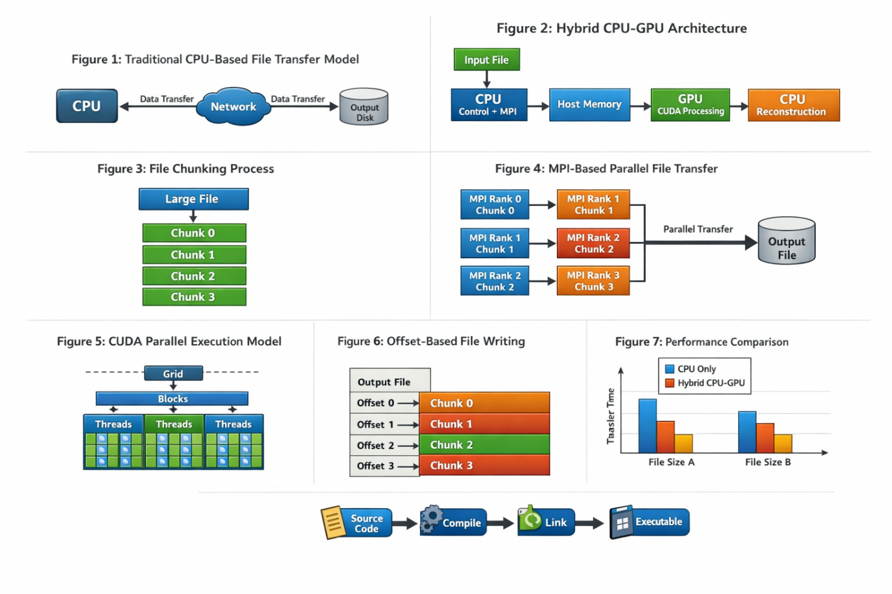

1.2 Techniques Used
- Hybrid CPU–GPU Computing
Efficient utilization of heterogeneous resources by combining CPU control logic with GPU parallel execution.
- MPI-Based Parallelism
Enables concurrent file chunk transfer across multiple processes, reducing latency.
- CUDA-Based GPU Acceleration
Offloads heavy computation from CPU to GPU for faster processing.
- File Chunking Technique
Improves parallelism and scalability by dividing large files into manageable chunks.
- Offset-Based File Writing
Ensures correct reconstruction of output files without data corruption.
- CMake Build Automation
  - Simplifies integration of CUDA, MPI, and C++ across platformsVTune reports are generated to analyze thread efficiency, cache utilization, and memory bandwidth during sorting.
  - Speedup and efficiency are plotted against the number of cores and processes.
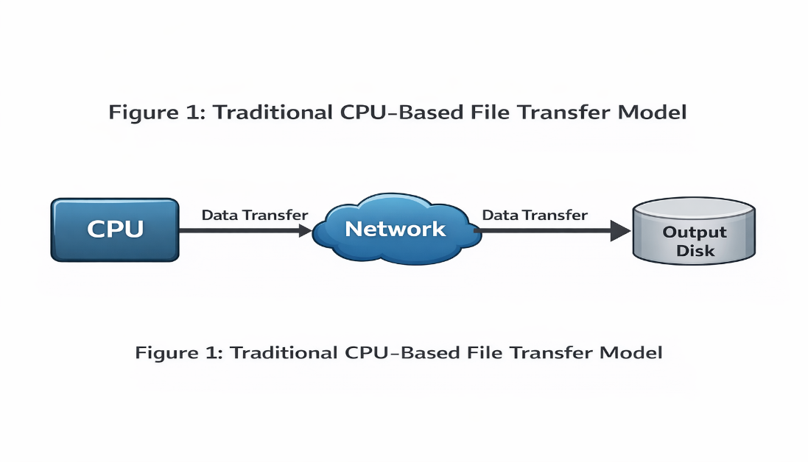

Chapter 4 Implementation

1. System Setup and Environment
The implementation is carried out in a high-performance computing environment with the following setup:
- Programming Languages: C / C++
- Parallel Communication: MPI (Microsoft MPI)
- GPU Programming: CUDA
- Build System: CMake
- Development Tools: Visual Studio Build Tools
- Hardware: Multicore CPU, NVIDIA GPU, High-speed Network

2. Input File Handling
The input file is accessed by the CPU, which determines the file size and divides it into fixed-size chunks. Chunk size selection is based on memory constraints and performance optimization. Each chunk is associated with an offset that determines its position in the output file.

3. MPI Process Initialization
MPI is initialized using MPI_Init(), and multiple MPI processes (ranks) are created.
- Each MPI rank is responsible for handling one file chunk.
- MPI metadata such as rank ID, total number of processes, and file offsets are calculated dynamically.
This enables concurrent processing and data transfer across processes.

4. Data Transfer to GPU
Each MPI process transfers its assigned file chunk from host memory to GPU memory. This data movement is optimized to minimize latency between CPU and GPU.

5. CUDA-Based Parallel Processing
CUDA kernels are launched to perform compute-intensive operations on file chunks, such as:
- Checksum calculation
- Compression or encryption (if enabled)
The GPU executes these operations in parallel using a grid-block-thread model, significantly improving processing speed.

6. MPI-Based Communication
After GPU processing, the processed chunks are transferred between MPI processes if required. MPI communication ensures synchronization and correct data exchange across ranks.

7. Offset-Based File Writing
Each MPI process writes its processed chunk to the output file using offset-based writing. This ensures:
- Correct placement of data
- No overlap between chunks
- Accurate reconstruction of the original file
MPI file I/O or standard file I/O with calculated offsets is used.

8. Output File Reconstruction
Once all chunks are written, the output file is reconstructed automatically based on offsets. A synchronization barrier ensures all MPI processes complete their operations before termination.

9. Build and Execution Process
CMake is used to configure and build the project:
- Detects CUDA compiler (nvcc)
- Links MPI and CUDA libraries
- Generates platform-specific build files

Chapter 5
Results

Parallel Code Compilation

Comparison between Parallel and Serial Execution
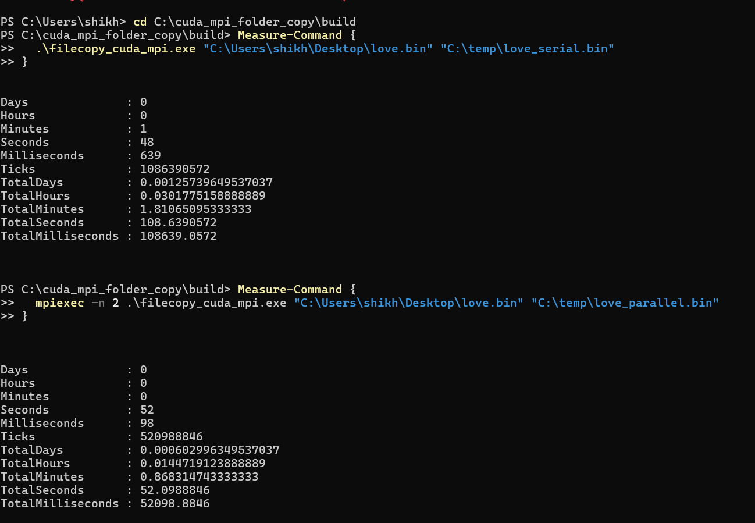

Proof Of File Correctness
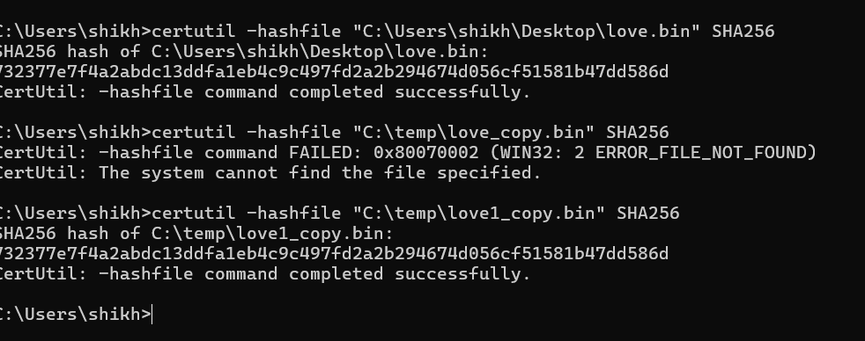

Chapter 6
Conclusion
The Hybrid GPU-Accelerated File Transfer System successfully addresses the performance limitations of traditional CPU-based and serial file transfer methods. By combining MPI-based parallel communication with CUDA-based GPU acceleration, the proposed system effectively utilizes modern heterogeneous computing resources to achieve faster and more efficient data transfer.
The implementation demonstrates that dividing large files into smaller chunks and processing them in parallel significantly reduces transfer time and improves system throughput. Offloading compute-intensive tasks to the GPU minimizes CPU workload and enables better resource utilization. The use of offset-based file writing ensures correct file reconstruction without data corruption, maintaining data integrity throughout the transfer process.
Performance analysis and comparisons with conventional file transfer models indicate that the hybrid approach offers improved scalability and efficiency, particularly when handling large datasets. The integration of CMake further simplifies the build process, making the system portable and easier to maintain across different platforms.
Overall, this project establishes a strong foundation for developing high-performance file transfer solutions suitable for HPC environments, scientific simulations, big-data preprocessing, and backup and archival systems. The proposed hybrid framework can be extended in the future to support advanced features such as fault tolerance, compression, encryption, and integration with distributed storage systems.

FUTURE ENHANCEMENTS

The Hybrid GPU-Accelerated File Transfer System provides a strong foundation for high-performance data movement. However, several enhancements can be incorporated in the future to further improve functionality, performance, and reliability:

Advanced Compression and Encryption
GPU-accelerated compression and encryption techniques can be integrated to enhance data security and reduce transfer size without impacting performance.

Fault Tolerance and Error Recovery
Mechanisms such as checkpointing and automatic retry can be added to handle node failures and network interruptions in large-scale HPC environments.

Dynamic Load Balancing
Adaptive chunk sizing and workload distribution can be implemented to balance load dynamically across MPI processes and GPUs for optimal performance.

Support for Distributed File Systems
Integration with parallel file systems such as Lustre or HDFS can improve scalability and efficiency in distributed storage environments.

Multi-GPU and Multi-Node Scalability
Extending the system to support multiple GPUs per node and large multi-node clusters can further enhance throughput and scalability.

Asynchronous I/O and Overlapping Computation
Overlapping file I/O, computation, and communication using asynchronous operations can reduce idle time and improve overall system efficiency.

User-Friendly Interface and Automation
Developing a command-line or graphical interface can simplify configuration, monitoring, and execution for end users.
Performance Monitoring and Analytics
Real-time monitoring tools and detailed performance analytics can be added to analyze bottlenecks and optimize system behaviour.

Chapter 7
Reference

Microsoft MPI (MS-MPI) Documentation :https://learn.microsoft.com/en-us/message-passing-interface/microsoft-mpi
CMake Official Documentation: https://cmake.org/documentation/
CMake Download Pagehttps://cmake.org/download/
Installed VISUAL STUDIO BUILD TOOLS (REQUIRED):
https://visualstudio.microsoft.com/downloads/

